Homework 1 Report

Student Name – email@nd.edu

# Design Decisions

Describe in this section your design choices when developing your solution. Specifically, include a description of:

* How are you extracting information from NVD (JSON data feeds or by using their API)?
* How did you tackle parsing of data feeds/pom files?
* How do you match CVE information to dependencies in a pom file? What heuristic(s) are you using?

You can also describe any technical challenges faced and how you overcame it.

# Knowledge Base Statistics

Describe here how your submission is persisting data, i.e., your database schema. Include a database diagram that showcase the table(s) you have on your database.

For example: “The database includes the tables shown in Figure 1. It contains 2 tables. The Question table….”

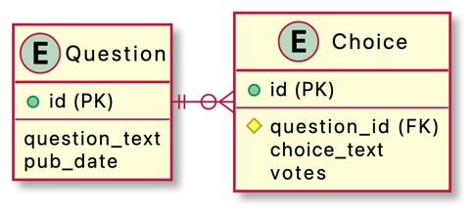

Figure 1 database schema

Also include basic statistics about the database by indicating:

* when was the knowledge base last updated (ex: January 23, 2023 at 2:14PM)
* how many rows in each table

# Research Synthesis

This section is only for those enrolled in CSE-60770. Include in here an answer to each question in Part 2.